NUTRITION FOR FAMILIES
********************************************************

A presentation for parents/guardians of elementary and middle school children
Free! Thanks to your One Community LG donations

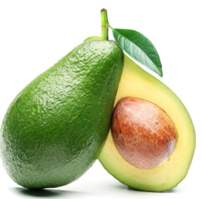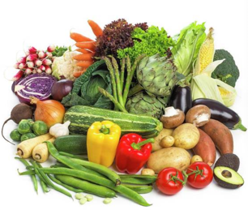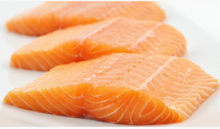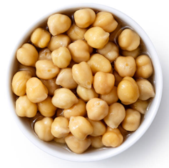

Date: Thursday, January 26th
Time: 6:00pm-7:30pm
Where: Fisher Middle School MPR

Join three nutrition experts for inspiration on how to teach your children to care about the food they eat in order to support healthy growth and development and to help them achieve their highest potential in school and beyond.

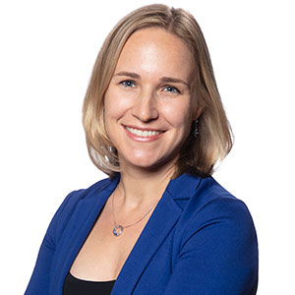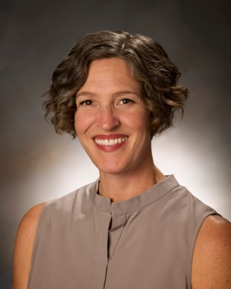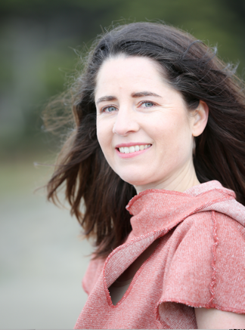

Dr. Anna Harbison is a double board-certified physician in pediatrics and pediatric cardiology at Stanford and mother of three in Los Gatos. She will highlight the cardiovascular ailments our youth face and the opportunities parents have to set them on the right track at a young age.

Rachael Brown is a local author and parent of two who will share her tips to help kids want to make healthy choices and how to prevent disease through food. Rachael holds certificates in plant-based eating and food and sustainability from eCornell. www.forforkssakebook.com

Sandra Fiz is a functional nutrition counselor with a passion for educating families on how their bodies work and how to improve their health. She will speak about what we can do through nutrition to help our kids achieve their highest potential at school and beyond. www.sandrafiznutrition.com

Come ready yourself to start creating the foundation of health to last a lifetime.

To sign up for this event please click the link below:

Sign-up here

